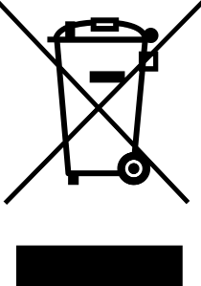 Waste Electrical and Electronic Equipment (WEEE)
Possum Ltd. recognize our responsibilities and obligations under all current National and European legislation and regulations and are totally committed to and in support of compliance with the European Union Directives on Waste, Electrical and Electronic Equipment (WEEE).
We continually work closely with our supply chain to ensure our complete compliance with the Directives in accordance with the current timetable, (as issued by the U. K. Department of Trade and Industry).
We are also committed to meeting our “importer” responsibilities and obligations, as defined in the scope of the Directives, for those products that we import into the U.K. market place.
We require our suppliers to ensure that all products, (that fall within the scope of the Directives), supplied after 13th August 2005 are marked with the “Do Not Dispose of in Household Waste” symbol as prescribed in article 10 of the WEEE Directive.

Possum Ltd. has an obligation to ensure the appropriate steps are taken for the recovery and recycling of WEEE from its customers. To meet this obligation we ask customers to contact the Customer Service Department (01296 461000) once the product has reached the end of its life.

Possum Ltd. is a member of the WeeeCare Compliance Scheme and therefore fulfil our obligations in accordance with the Waste Electrical and Electronic Equipment Regulations 2006.
Environment Agency Producer Registration Number WEE/EA1076RX

