The EU Waste Batteries and Accumulators Directive requires all Member EU countries to maximise the separate collection, treatment and recycling of waste batteries and accumulators. The UK Battery Regulations (derived from this Directive) applies to 3 types of batteries and accumulators placed on the market in the UK: Portable, Industrial, and Automotive.

Under Regulation 5 of the Batteries and Accumulators (Placing on the Market) Regulations 2008, “Producers” are required to mark all relevant batteries and battery packs placed on the market in the UK with the “crossed out wheeled bin symbol” to remind consumers not to discard batteries and accumulators in the domestic waste stream. Possum Ltd. encourages all of its customers to make note of this symbol and avoid putting any batteries in your domestic waste bin(s) or container(s).

Waste batteries & battery packs should either be placed in your local battery recycling point or sent to Possum Ltd.

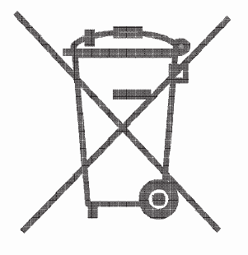

Possum Ltd. supports the reuse and recycling of batteries as there are several environmental benefits of doing so, such as: Reduction of raw material and energy usage, prevention of landfill, prevention of hazardous and/or toxic materials present in some batteries contaminating the environment. As a Producer under the UK Battery Regulations, Possum Ltd. complies with its Producer Obligations by being registered as a Member of the BatteryBack Compliance Scheme and has been assigned the following Battery Producer Registration Number – BPRN07726

